**7 SEGMENT DISPLAY USING 8051 USING PROTEUS**

**AIM:**

Write an assembly language program for 7 Segment Display Using 8051 using Keil and Proteus

**SOFTWARE REQUIRED:**

* Proteus 8 software.

**PROGRAM:**

ORG 000H

UP:MOV P2,#0C0H

ACALL DELAY

MOV P2,#0F9H

ACALL DELAY

MOV P2,#0A4H

ACALL DELAY

MOV P2,#0B0H

ACALL DELAY

MOV P2,#99H

ACALL DELAY

MOV P2,#92H

ACALL DELAY

MOV P2,#82H

ACALL DELAY

MOV P2,#0F8H

ACALL DELAY

MOV P2, #80H

ACALL DELAY

MOV P2,#90H

ACALL DELAY

DELAY: MOV R5,#10

H1:MOV R4,#180

H2:MOV R3,#255

H3:DJNZ R3,H3

DJNZ R4,H2

DJNZ R5,H1

RET

END

**CIRCUIT DIAGRAM:**

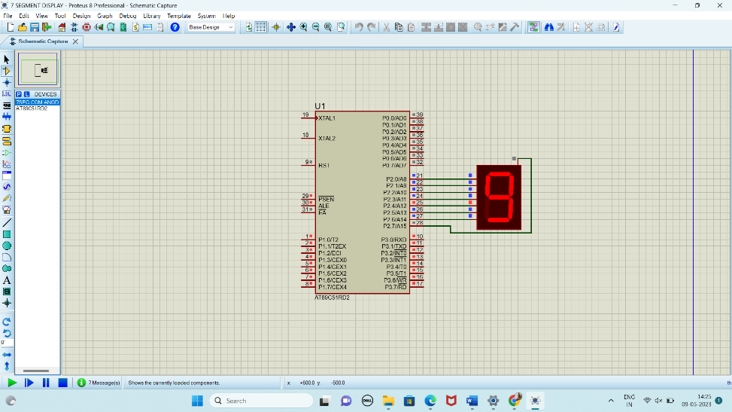

**RESULT:**

Thus the program has been successfully verified and executed.